Day 20 – 25/07/2025

// Task001: SRP Implementation  
  
package Day20.Customers;  
  
public class SRPImplementation {  
 public static void main(String[] args) {  
 Customers customers = new Customers("shiro", "43");  
 ManageFiles manageFiles = new ManageFiles();  
 manageFiles.saveData(customers);  
 }  
}

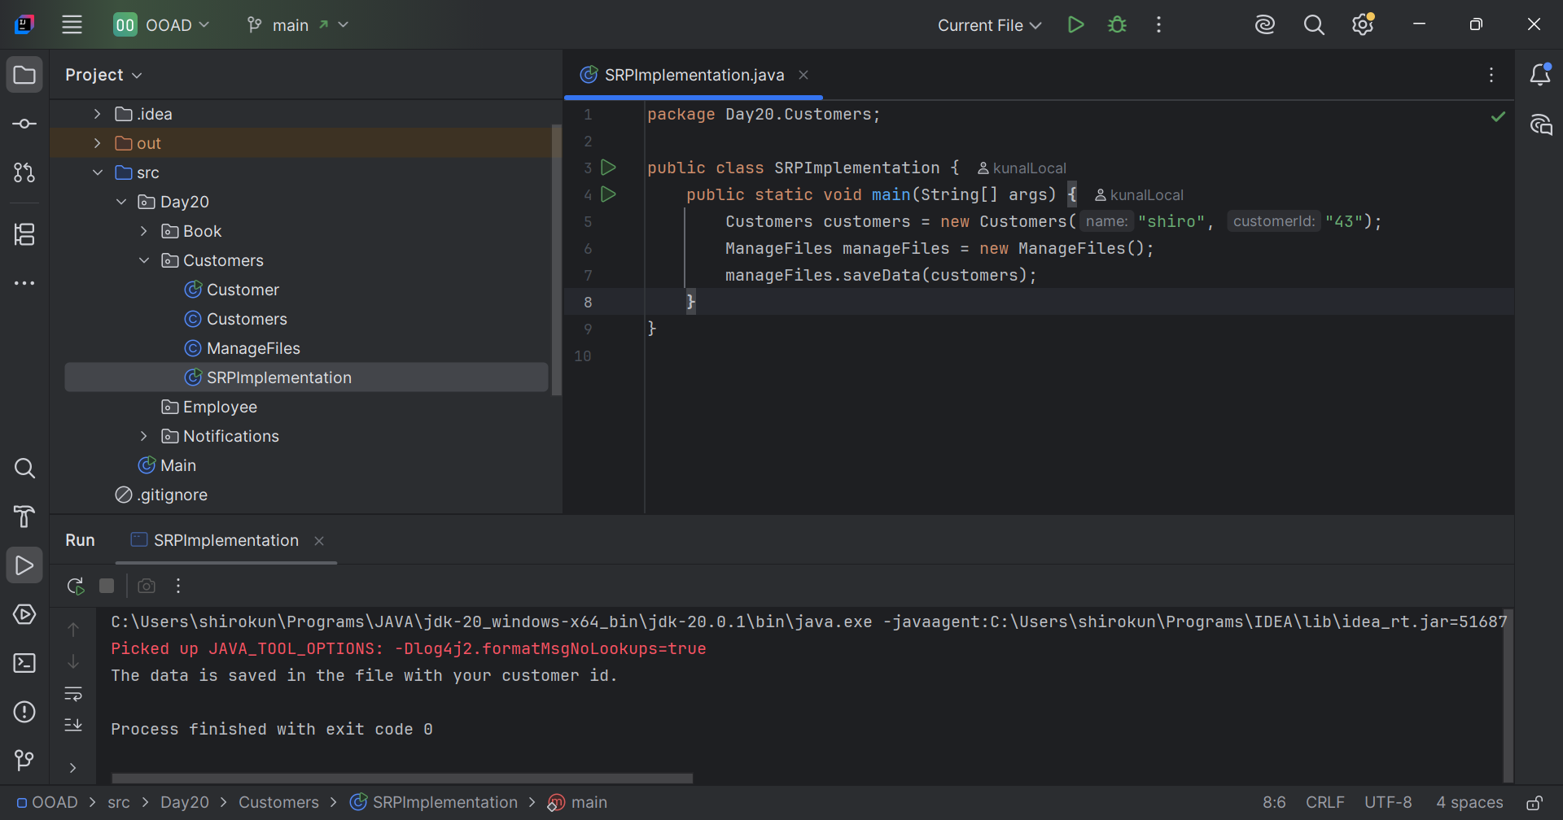

// Task002: OCP Implementation  
  
package Day20.Notifications;  
  
public class NotifHandler {  
 public static void main(String[] args) {  
 BankNotifications emailNotif = new EmailNotif();  
 BankNotifications mobileNotif = new MobileNotif();  
 BankNotifications whatsappNotif = new WhatsAppNotif();

emailNotif.sendOTP("email");  
 mobileNotif.sendOTP("");  
 whatsappNotif.sendOTP("");  
 }  
}

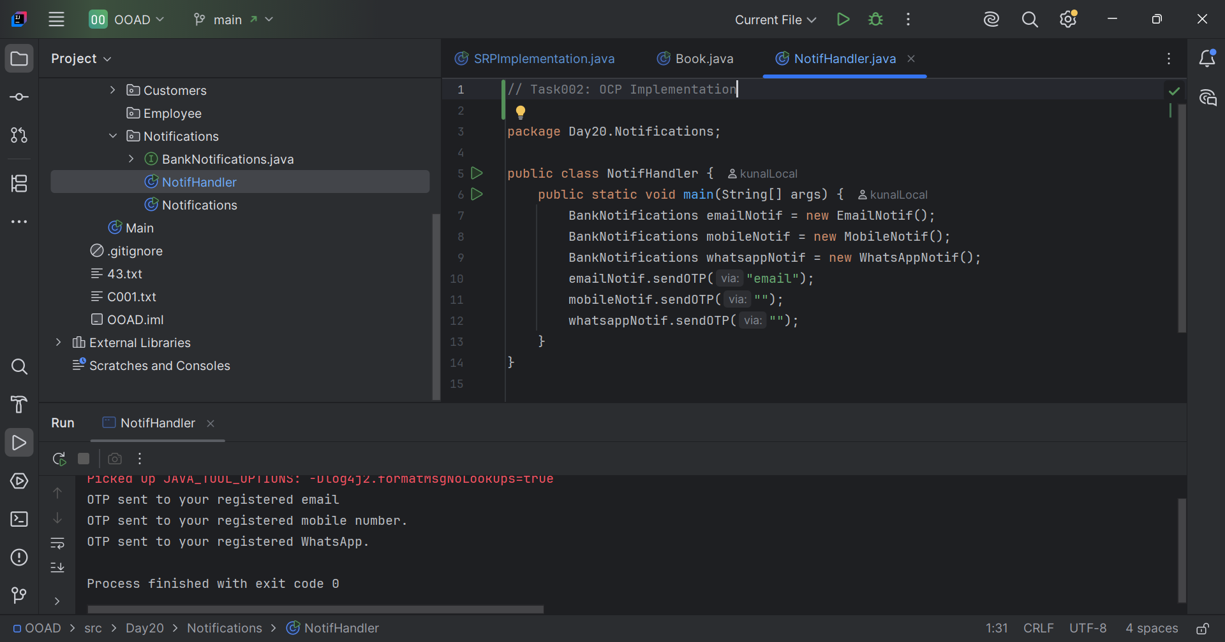

// Task003: The below is violating SRP, complete it and  
// also implement the SRP principle and rewrite the code.  
  
package Day20.Book;  
  
public class Book {  
 public static void main(String[] args) {  
 BookDetails bookDetails = new BookDetails("shiro", "Kunal", 200);  
 BookFormater bookFormater = new BookFormater();  
 PriceCalc calc = new PriceCalc();

System.*out*.println("Selling price of "+bookFormater.formatTitle(bookDetails.getTitle())+  
 " written by "+bookDetails.getAuthor()+  
 " is: "+calc.discountedPrice(bookDetails.getPrice(), 0.25));  
 }  
}

